**PROJECT DESIGN**

**Components Used:**

* 6 x 1 KΩ Resistors
* 6 x Small Buttons
* 1 x 10 KΩ Resistor
* 10µF and a 100nF Capacitor
* 555 Chip
* 8R Speaker
* Battery Clip and Switch
* 470 Ω Resistor and a LED
* 9V Battery
* Breadboard
* Wire Leads

**Circuit Connection:**

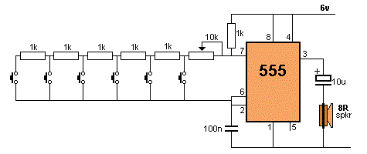

**Description:**

A breadboard is used to place above connections in it. The buttons are used as keys of piano. 1K resistors are used between the buttons to vary the potential across each button such that there is a different sound produced from each button.

One end of the buttons is connected to pin 7 of IC 555 through the 10K and 1K resistors. Other end of the buttons is connected to common point of 100nF and pins 6 and 2 of IC 555.

The other end of the 100nF capacitor is connected to a common ground.   
Similarly pin 1 of IC is connected to the ground. The pin 3 of IC 555 is the output pin so the 8R speaker is connected to it through the 10µF capacitor.

Pins 8 and 4 of IC and other terminal of 1K resistor is given to supply, in this case a 9V battery is used. The 9V battery is connected to the board using a switch. A LED is used to indicate whether the switch is ON or OFF.

This circuit is simple and we can also change the resistor values to get different pitches. Using this basic circuit, a synthesizer can be made using potentiometers.

------------------------------------ **THANK YOU** ----------------------------------------